EE5356 LAB Assignment #3

Color Transformation

The test image, Girl256color.raw (the size is 256*256 pixels) , for this assignment is available at the class website.

Problem 1: RGB component decomposition

1) Decompose a given 24bit color image (raw format) into 3 Red, Green,
and Blue components and show those images in your report and explain
the procedure (how to get these.)

2) Reconstruct the color image from these three RGB components, and
show the reconstructed color image with your explanation.

NOTE:
1: Please explain in writing and not just by attaching a source code.
2: Since the format of an image is raw format, you cannot use any builtin
MATLAB function to do this assignment. You have to open the file by
your self to access to data in the image.
3: You can use ‘image.m’ function to display the reconstructed color image
if you use MATLAB. See the details by typing ‘help image’ in the
MATLAB command window.

Problem 2: Color transformation

Given the conversion of the gamma corrected and normalized tri-stimulus
analog signals R, G, and B to component YUtVt signals is defined as
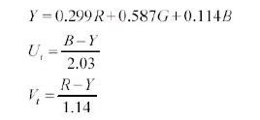
i.e.
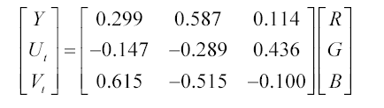
and the inverse transform is:
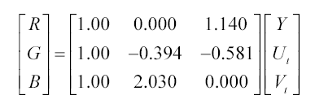

RGB to digital component YdCbCr conversion is given by
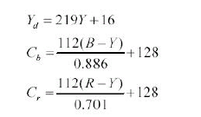
i.e.,
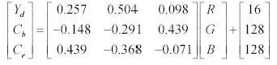
And the inverse transform is:
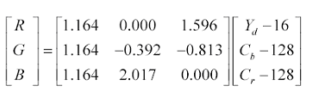
where digital luminance, Yd, has a range of (16-235) with 220 levels
starting at 16, and digital chrominance difference signals, Cb and Cr, have
a range of (16-240) with 225 levels centered at 128, then apply these
transforms to get YUtVt and YdCbCr from RGB components you
obtained in problem 1. Show all the 6 components.

NOTE:
1: R=G=B=1 corresponds to reference white C of unity luminance.
2: You may use ‘imshow.m’ to do the scaling of those obtained
components which have a range of (0 1.0) .

Hint:
The steps to be followed:
- Open colored raw file
- Convert open file into an image of 256*256*3
- RGB component decomposition
Red components are present at 1,4,7...
Green '' '' 2,5,8...
Blue " " 3,6,9...
- Break RGB image into R-image, G-image and B-image
- Initialize zero vectors of size 256*256 for display
- Display R, G, B component.

